Age Dependence of Central Pressure Generalized Transfer Function: An In Silico Approach
I. Abal, R. Canaglia, E. Ipar, R. L. Armentano y L. J. Cymberknop
Group of Research and Development in Bioengineering (GIBIO), Universidad Tecnológica Nacional, Buenos Aires, Argentina
ljcymber@frba.utn.edu.ar
Abstract. The Generalized Transfer Function (GTF), defined as the harmonic relationship between peripheral blood pressure and aortic pressure, is usually utilized for the non-invasive estimation of Central Aortic Pressure (CAP). Accordingly, one-dimensional (1D) models have gained significant prominence in recent years, due to their versatility to accurately reproduce the behavior of arterial waveforms and low computational cost. On this basis, GTF morphology and its potential variations with age were studied, in terms of a set of digitally simulated individuals. Although the obtained GTFs were in agreement with published real measurements, corresponding functions to age groups lower than 40 years behave differently than GTFs of older groups. This could indicate the convenience of considering differentiated GTFs functions in terms of the subject age (a ‘patient specific’ approach).
Keywords: Generalized Transfer Function, 1D Modelling, Ageing
- Introduction
The relationship between pressure waves in the central aorta and peripheral arteries is used to the non-invasive estimation of Central Aortic Pressure (CAP) and to study the effects of aging and other factors on the arterial system (AS) [1]. Indeed, CAP represents the blood pressure measured at the output of the left ventricle, where the main artery of the AS that carries blood from the heart to the rest of the body. In this sense, the Generalized Transfer Function (GTF), defined as the harmonic relationship between peripheral blood pressure and aortic pressure [2], is considered ‘unique’ since it involves the complex interactions between the heart, arteries, and surrounding tissues that affect pressure wave propagation [3]. Its utility has been well-validated in clinical studies, where CAP derived from GTF showed high correlation with invasively measured CAP in hypertensive patients. Although there is some debate regarding the real impact of age, evidence suggests that GTF is relatively age-independent [4].
With the accelerated development of computational processing, the study of the AS has shifted towards the use of computational models. Understanding the interaction between pressure and flow waveforms in relation to AS properties is crucial for preventive and predictive purposes, especially when certain disease predictors cannot be directly determined in daily clinical practice [5]. The ability to ‘simulate’ the arterial structure has enhanced the understanding of the dynamics of certain pathologies that affect the vascular structure and offers the opportunity to generate ‘digital individuals’. Particularly, one-dimensional (1D) models have gained significant prominence in recent years due to their versatility and low computational cost. Previous works have shown that 1D modeling exhibits notable capacity in capturing essential characteristics of these waveforms, even compared to three-dimensional (3D) modeling [6,7].
In virtue of the abovementioned, this study was focused on evaluating the age-dependence of GTF, using a population of digitally simulated individuals (‘in silico’ approach) [8], in order to determine how its behavior is aligned with the experimental existing evidence.
- Materials and Methods
  - Pulse Wave Database
In this study, we used a population of digitally generated individuals from the database (DB) published in [8], where an amount of simulated blood pressure waveforms (SBPW) were provided, representative for adults without pathologies of different age ranges. The DB has information on several hemodynamic parameters and SAPW time series of 4374 subjects, at 13 different arterial points of the AS. The individuals are equally divided into the six age groups, as shown in Fig. 1.

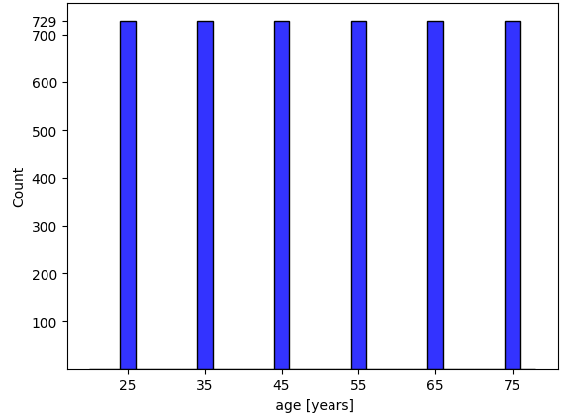
Fig. 1. Distribution of digital individuals according to their age group.

2.2 Arterial Transfer Function Assessment

GTF was obtained from each of the individuals between radial and central SBPWs. To this end, a spectral analysis of each waveform was assessed (1), as follows [9]:

$GTF(f) = XR(f)/XC(f)$ (1)

where GTF(f) corresponds to the spectrum of the Generalized Transfer Function, XR(f) is the spectrum corresponding to the Radial Arterial Pressure pulse (RAP) and XC(f) is the spectrum corresponding to the PAC pulse. The Python platform version 3.10 was used for the study.

2.3 Statistical Analysis

Once the GTFs of the entire BD were obtained, a statistical study was carried out, with the main objective of defining dependencies with the age of the evaluated subjects. For this purpose, the GTF curves were grouped by age range, where their mean and standard deviation were determined. Subsequently, an ANOVA test with Bonferroni correction was applied to determine the significance of the difference between the maximum of GTF values of each age group (characteristic point of the curve) and the significance of the difference between the GTF values at 20 Hz frequency (decay zone of the curve). The normal distribution of each age range was verified by the Shapiro-Wilk test.
- Results
Fig. 2 shows the distribution of mean brachial pressure (MBP) values for each age group. The average GTF for each age range, along with the corresponding deviation, is depicted in Fig.3. As can be seen, the obtained results from digital subjects are in agreement with previous studies [4].

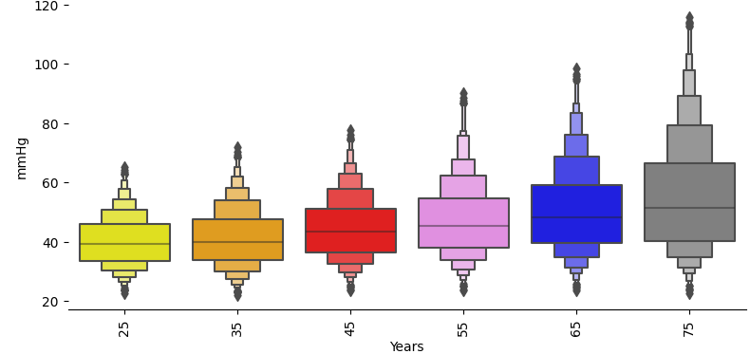
Fig. 2. Distribution of mean brachial pressure (MBP) according to their age group.

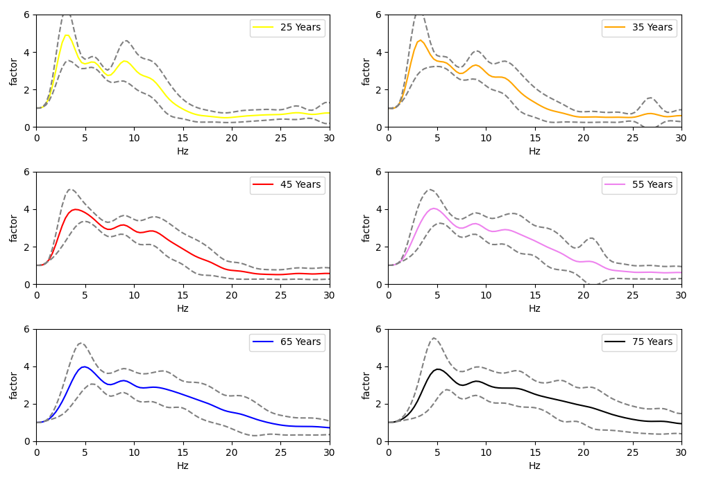
Fig. 3. Average GTF and standard deviation margins for each age group.
Fig. 4 presents the results of the average GTF for each age range. A slight progressive differentiation between the average GTF for each age group is observed, and a similarity between the curves corresponding to subjects aged 25 and 35 years is found. On the other hand, affinity among the groups of 45, 55, 65, and 75 years is visualized, mainly at low frequencies. Additionally, peak occurrence of 25 and 35 years old curves seems to be earlier than the rest of age groups.

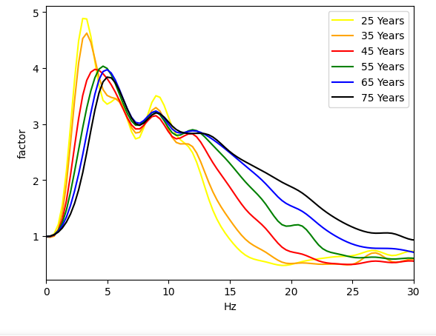
Fig. 4. Average GTF according to age group.
Fig. 5 shows the distribution of the studied characteristic values of the GTF (maximum value and factor for 20Hz). A higher dispersion can be seen as the individual’s age increases. The dispersion is particularly greater for the 45 years old age group in comparison with the rest of the subjects.

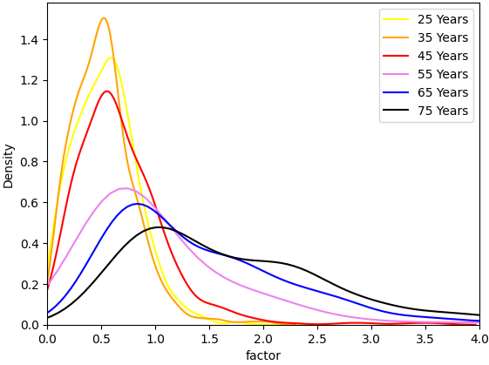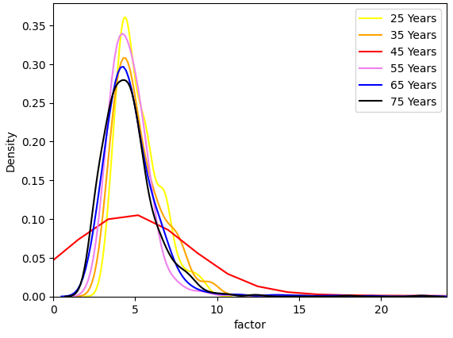
Fig. 5. Density plots for maximum factors and 20 Hz frequencies by age group.
The results obtained from the comparisons between groups, in relation to the GTF values for 5Hz and 20Hz are detailed in Table 1. P<0.05 was considered statistically significant.
Age Group | Maximal GTF Values (5Hz) | GTF Values at 20 Hz
25-35 | NS | NS
25-45 | NS | P<0.001
25-55 | P<0.001 | P<0.001
25-75 | P<0.001 | P<0.001
55-75 | NS | P<0.001
55-65 | NS | P<0.001
65-75 | NS | P<0.001
35-45 | NS | P<0.001
35-55 | P<0.001 | P<0.001
35-75 | P<0.001 | P<0.001
45-75 | NS | P<0.001
Table 1. Results obtained from the comparisons between groups, in relation to the GTF values for 5Hz and 20Hz are detailed in Fig. 5. P<0.05 was considered statistically significant. NS: Not Significant.
- Discussion
This study examines the GTFs dependence on age in a population of digitally simulated individuals. The results obtained are consistent with the behavior observed in real measurements, demonstrating the versatility of 1D modeling [4]. However, a significant difference was observed in the younger group (under the age of 40), primarily at the maximum point near 5Hz as well as in the values for the 20Hz frequency (decay range). Despite the advantages of GTF, there are effectively some limitations in its use, as it may lose precision in individuals with certain conditions or pathologies. In [10], CAP derived from GTF was observed to predict cardiovascular events in patients with diabetes mellitus, where slight differences in GTF appeared in individuals with such pathological conditions, who tend to have stiffer arteries. Moreover, other studies have shown lower precision in individuals with severe atherosclerosis, compared to those with mild or absent [4], and in those engaging in vigorous exercise compared to non-exercisers [1]. Conversely, some other studies have demonstrated that GTF does not change significantly with age [4].
Particularly, in [11] the capacity of a multiscale mathematical model and a GTF method to estimate the invasive aortic pressure was compared. The mathematical model resulted in a slightly larger dispersion of the estimations than the GTF method but provided better estimation of the aortic pulse pressure. In the present study, GTF and its relationship with age in a population of digitally simulated individuals was analyzed. A significant variation of GTF was observed, specifically in the peak around 5 Hz and the decay range (20 Hz), within the group under 40 years old. The obtained results showed that GTF functions corresponding to individuals with an average age of 25 and 35 years manifested a similar behavior, while the remaining functions (average ages of 45, 55, 65 and 75 years old) differ from each other as the frequency increases.
Furthermore, with regard to the maximum values of GTF functions, significant differences were found for the 25 and 35 average age groups, with respect to the 55 years and older age groups, but not within these two age groups. The age group of 45 years did not present significant differences with any of the others, this is due to the fact that the dispersion of the maximum values for this group was greater than in the others, thus denoting a ‘transition’ period in the subjects between the early ages GTFs and advanced age ones.
The abovementioned is in agreement with an age dependence in GTF, which is supported by previous studies such as [12], which emphasized the importance of considering age when determining reference values for CAP. According to [13], using CAP may be useful in excluding hypertension in young and middle-aged individuals, where GTF could behave differently from the other age groups. In light of our results, we suggest that considering an age-specific GTF, especially for younger individuals, could be beneficial, given the similarity we observed between corresponding GTFs of 25 and 35 years old groups. Additionally, the obtained results suggest that the adjustment of GTF based on age might improve the accuracy of CAP prediction (patient specific approach).
References
- Karamanoglu, M., O'Rourke, MF, Avolio, AP, & Kelly, RP. Analysis of the relationship between central aortic and peripheral upper limb pressure waves in man. American Journal of Physiology-Heart and Circulatory Physiology, 259(1), H159-H167. (1990).
- Gao, M., Rose, W. C., Fetics, B., Kass, D. A., Chen, C.-H., & Mukkamala, R. A Simple Adaptive Transfer Function for Deriving the Central Blood Pressure Waveform from a Radial Blood Pressure Waveform. Scientific Reports, 6, 33230, (2016).
- O'Rourke, M. F., Avolio, A. P. Arterial transfer functions: background, applications, and reservations. Journal of the American College of Cardiology, 15(6), 1147-1157, (1990).
- Cheng, H.-M., Lang, D., Tufanaru, C., & Pearson, A. Measurement accuracy of non-invasively obtained central blood pressure by applanation tonometry: A systematic review and meta-analysis. International Journal of Cardiology, 167(5), 1867–1876, (2013).
- Willemet, M. & J. Alastruey, “Arterial pressure and flow wave analysis using time-domain 1-D hemodynamics”, en Annals of biomedical engineering, 43, 190-206 (2015).
- Xiao, N., Alastruey, J., Figueroa, C. A systematic comparison between 1-D and 3-D hemodynamics in compliant arterial models. Int. J. Numer. Methods Biomed. Eng., 30:204–231 (2014).
- Reymond, P., Merenda, F., Perren, F., Rüfenacht, D., Stergiopulos, N. Validation of a one-dimensional model of the systemic arterial tree. Am. J. Physiol. Heart Circ. Physiol. 297:H208–H222 (2009).
- Charlton, P. H., Mariscal Harana, J., Vennin, S., Li, Y., Chowienczyk, P., Alastruey, J. Modeling arterial pulse waves in healthy aging: a database for in silico evaluation of hemodynamics and pulse wave indexes. American Journal of Physiology-Heart and Circulatory Physiology. 317(5), H1062-H1085 (2019).
- Parati, G., Saul, J. P., Di Rienzo, M., & Mancia, G. Spectral Analysis of Blood Pressure and Heart Rate Variability in Evaluating Cardiovascular Regulation. Hypertension. (1995).
- Hope, T. A., Ladich, E., O'Rourke, M. F. Central aortic pressure: a novel index of cardiovascular risk in diabetes?. Diabetes Care, 31(10), 2079-2085, (2008).
- Guala, A., Tosello, F., Leone, D., Sabia, L., D’Ascenzo, F., Moretti, C., & .Milan, A. Multiscale mathematical modeling vs. the generalized transfer function approach for aortic pressure estimation: a comparison with invasive data. Hypertension Research, 42, 690–698. (2019).
- Herbert, A., Cruickshank, J. K., Laurent, S., & Boutouyrie, P. Establishing reference values for central blood pressure and its amplification in a general healthy population and according to cardiovascular risk factors. European heart journal, 35(44), 3122-3133, (2014).
- Saladini, F., Santonastaso, M., Mos, L., Benetti, E., Zanatta, N., Maraglino, G., ... & HARVEST Study Group. Isolated systolic hypertension of young-to-middle-age individuals implies a relatively low risk of developing hypertension needing treatment when central blood pressure is low. Journal of hypertension, 29(7), 1311-1319, (2011).

